Phishing Email Analysis – Imaginary Bank Case Study

Project Description
As part of a cybersecurity training exercise, I investigated a suspicious spear phishing email sent to an executive at Imaginary Bank. The email appeared to come from the board and requested the installation of a collaboration tool called ExecuTalk. My task was to analyze the email, identify phishing indicators, and decide whether it should be quarantined.
This project demonstrates my skills in phishing detection, email header analysis, link inspection, and incident reporting.

Objective
- Detect clues that indicate the email was malicious.
- Analyze the header, message body, and embedded links.
- Validate if the email was part of a phishing attempt.
- Recommend whether to allow or quarantine the email.

Suspicious Email Example
Header:
From: imaginarybank@gmail.org
Sent: Saturday, December 21, 2019 15:05:05
To: cfo@imaginarybank.com
Subject: RE: You are been added to an ecsecutiv's groups

Body:
Conglaturations! You have been added to a collaboration group ‘Execs.’

Downlode ExecuTalk to your computer.

Mac® | Windows® | Android™

You're team needs you! This invitation will expire in 48 hours so act quickly.

Sincerely,
ExecuTalk©
All rights reserved.

Malicious Site Example
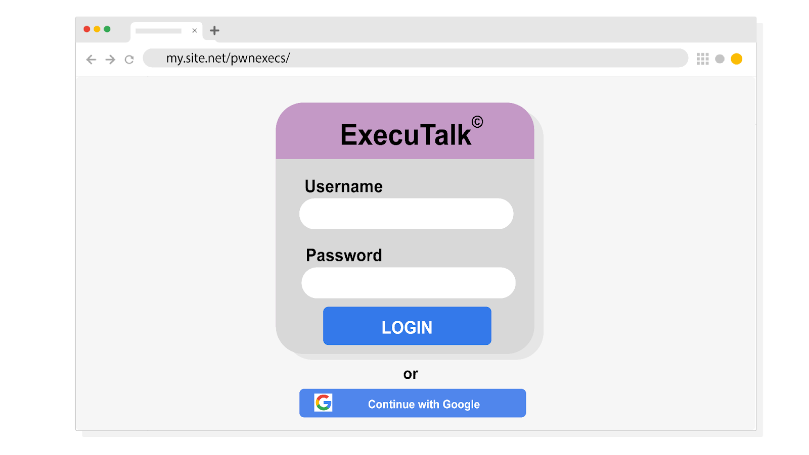

How It Was Checked
- Header Analysis
  - Domain check: Sender email was from imaginarybank@gmail.org instead of the company’s domain (@imaginarybank.com).
  - Grammar check: Subject line contained errors (“You are been added”, “ecsecutiv’s”).
  - Technique used: Manual inspection of domain and subject line.
- Body Analysis
  - Branding attempt: The attacker added fake branding (ExecuTalk©).
  - Download options: Multiple platforms listed (Mac®, Windows®, Android™) to appear credible.
  - Urgency tactic: Invitation with a 48-hour time limit—a common social engineering trick.
  - Technique used: Reading for manipulative language, urgency, and legitimacy cues.
- Link Inspection
  - Hover-over check: All download options redirected to
my.site.net/pwnexecs/ instead of an official corporate domain.
  - Observation: The login page mimicked ExecuTalk branding but hosted on a suspicious external site.
  - Technique used: Safe hover-over inspection to reveal hidden URLs.

Findings
- Header red flags: Fake domain, spelling errors.
- Body red flags: Urgency tactics, fake branding, exaggerated legitimacy attempts.
- Link red flag: URL mismatch, redirecting to a malicious site.

Conclusion & Action Taken
The investigation confirmed the email was a phishing attempt designed to trick the executive into downloading malware or entering credentials on a fake login page.
✅ Final Decision: The email was quarantined to prevent compromise.

Skills Demonstrated
- Email header analysis (domain & grammar check)
- Phishing detection through social engineering cues
- Safe link inspection & validation
- Cybersecurity reporting & threat documentation

